Single pattern in java

Singleton means, In object oriented programming, A singleton is a special class that can create only one object ( or ) single instance at a time. If u try to create another object it points to that object only

Singleton Pattern In Java || How to achieve Singleton In Selenium WebDriver.

~~Singleton Class in Java:

In object-oriented programming, a singleton class is a class that can have only one object (an instance of the class) at a time. After first time, if we try to instantiate the Singleton class, the new variable also points to the first instance created

So whatever modifications we do to any variable inside the class through any instance, it affects the variable of the single instance created and is visible if we access that variable through any variable of that class type defined

. ~~~To design a singleton class:

1. Make constructor as private.

2. Write a static method that has return type object of this singleton class. Here, the concept of Lazy initialization in used to write this static method.

Normal class vs Singleton class: Difference in normal and singleton class in terms of instantiation is that, For normal class we use constructor, whereas for singleton class we use getInstance() method.

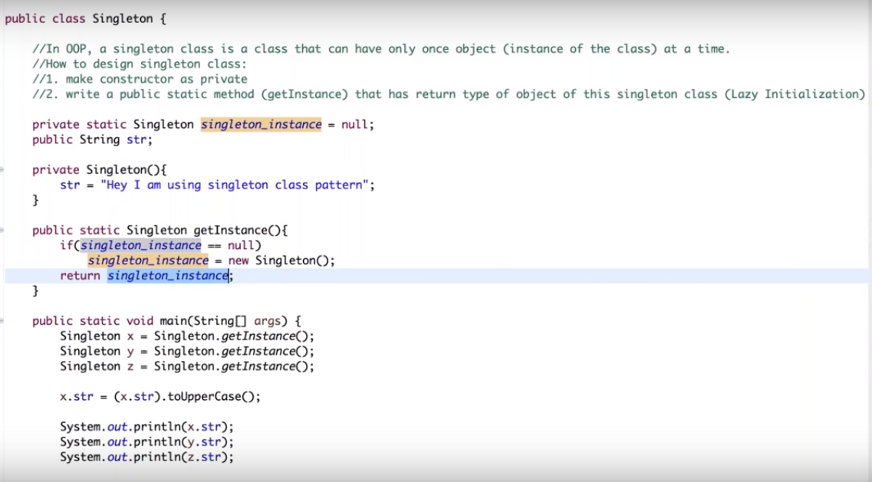

Output



Changes done by ‘Z’, impact on remaining x and y also

